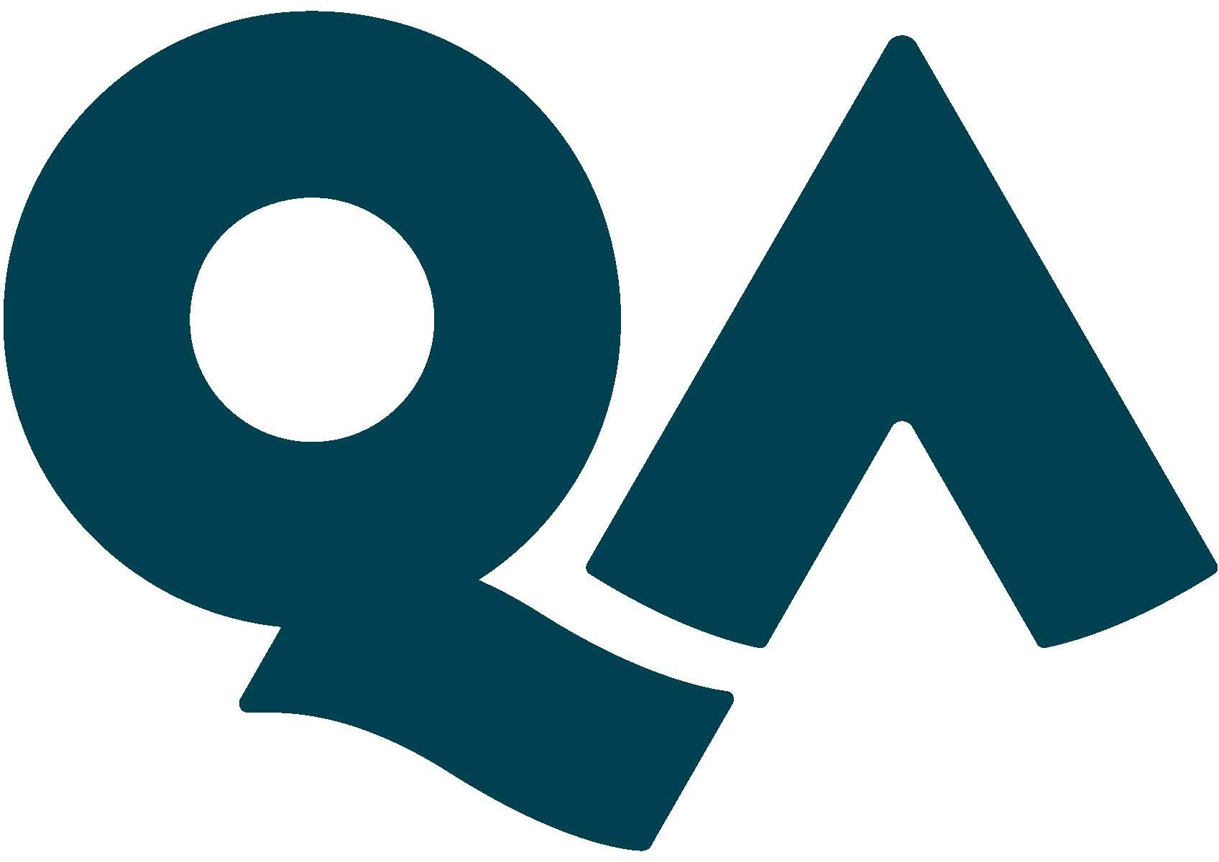

JOB
DESCRIPTION

- Job specifics
Job Title: | Head of Content Design and Development
Reports to: | Director of Learning Content & Creative
Location: | Hybrid/London (in IH at least every other week)
Department: | Content & Creative

- About the role
What you’ll be doing? | Leading the team to develop and design best in class learner journeys and embedding evidence-based learning methodology within the larger content function.  Collaborating on creation and integration of content from multiple brands, ensuring consistent approach and voice.  Managing the integration of two multifunctional teams, and embedding a unified culture and working practices
Key Responsibilities | - Lead team to design and develop high quality, dynamic learning content, utilising a range of media and methods  - Manage continuous improvement of team processes and project management in learning architecture and design  - Collaborate on development of the group style guide and the integration of appropriate approaches to writing for learners across group content  - Proactively upskill the team in evidence-based learning design principles and approaches  - Seek out opportunities to embed storytelling and other creative elements in learning content, and oversee implementation  - Manage UX improvements to learner journey in the group platform in collaboration with CE&Q and Product teams  - Support Curriculum team with best practice approaches to learner research and analysis, and lead on special projects  - Collaborate on product boards and represent the CD&D team in strategic projects  - Lead on programme reviews and workshops, supporting continuous improvement to the learner journey in collaboration with CE&Q team  - Foster strong links with adjacent functions, including Curriculum, Product and R&D teams  - Manage resources and build capacity within the team
KPIs & SLAs | - Outcomes for learners – the ultimate measure for the quality of learning design is in supporting learners and clients to achieve their objectives – either through pass rates, retention or application at work.  - Project management – with success defined by both project delivery and quality of governance
Key Working Relationships | Collaborative relationships with heads of Content Experience and Quality, Product, R&D, Product Marketing and Curriculum teams.  You will also need to be able to present on strategic initiatives to senior leaders and ExCo members.

- About You
Skills & Abilities | - Excellent people management and stakeholder management skills  - Broad understanding of learning principles and methodologies  - Familiarity with different media, their role and potential use cases in learning design  - Strong learner focus, and design thinking ethos  - High performance and quality standards balanced by empathy for individuals and teams  - Proactive, collaborative and strategic communication approach  - Comfort level with change and ambiguity  - Commercial mindset
Your Experience | - Track record in Learning Design, Content and/or Product Development, including complex projects  - Experience in team building and professional development of team members  - Experience with change management and embedding culture change
Your Qualifications | L&D or Education and management experience is essential. A HE qualification in a related area is preferred.
What you’ll bring to QA | - Positive, proactive and committed to delivering high quality work on time  - Good planner and problem-solver  - Must demand high standards and set the bar through consistent and high-quality personal approach.  - Must be able to work at a detailed level but understand the bigger context  - Able to build rapport quickly through remote intervention  - Team player

- About QA
About us | We shape the next generation of technologists, leaders and innovators.  By powering potential – the potential of over a quarter of a million learners a year. We empower them to push boundaries and thrive in the workplace.  Why we do learning  For over 30 years, we’ve worked in technology – where the impact of great learning is changing the world.  A bold statement, but hear us out. We are right at the centre of a technological revolution. Devices are not just connecting people, cities and countries – they are connecting to each other, collecting data and using it to learn and make themselves better. Soon we will have cars that can drive themselves, fridges that make sure we never run out of milk and computers that can learn from their own mistakes.  Driving this revolution? People.  And this is where we come in.  People advancing their knowledge in technology – to enrich society – build a new culture – better how we live our lives, and how we work together.  People are learning to use technology to drive phenomenal change. This is our passion – powering their potential.
We promise to be | Bold  - Ambition is great. We set ambitious targets – holding ourselves and others to ever-higher standards.  - We contribute (insightfully) to the debate inside and outside QA.  - We move. Quickly. We respond to your needs – fast.  Collaborative  - We spend time getting to know you – our learners and our customers – to earn your trust.  - We connect a solution to your problem – we have tonnes of different services to help you.  - We’re the positive person who actively gets stuck in to solving problems.  Progressive  - We embrace change – and support it.  - We challenge ourselves to use the latest technologies and methods – no matter how out there.  - We’re curious – about what you do, about what the person next to you does, about our customers and our learners.
What’s on offer? | Learning is not just a service we provide, it’s a way of life at QA, and we try to ensure that everyone has the opportunity to take advantage of our huge and varied range of learning and development options, so everyone is eligible for 3 Training Days every year, to focus on subjects they’re interested in.  We also know that many people like to “give back” and so we offer 2 paid Charity Days each year to support your chosen charity in whatever way you choose. And if you get involved in charity fundraising, QA will also double any sponsorship money raised, up to £250. This is over and above the charitable activities that we encourage through our annual QA fundraising drives – you can get involved with this as much or as little as you like. We see it as a great way to foster team building too.  We all need to take time out to recharge our batteries from time to time and enjoy some down time, so we provide a fairly generous 25 days’ holiday per annum (rising to 28 days after 5 years) – with the option to buy more if you wish.  It’s important, too, to plan for the future and ensure we are able to maintain the lifestyle we have worked so hard to achieve, once we retire from the hurly burly and slow down to enjoy our later years, so we offer a defined contribution pension plan and will match your contributions up to a maximum of 4% of your basic salary.  Then there are two of our core benefit offerings, not the most exciting, but we consider it important to ensure everyone has the peace of mind provided by Life Assurance (4x your basic salary) and Permanent Health Insurance (after a qualifying period) in the event that ill health, or worse, disrupts our plans.  And finally, a few fringe benefits to assist with travel and lifestyle choices:  - Season ticket loan  - Corporate gym membership  - Cycle to work scheme

