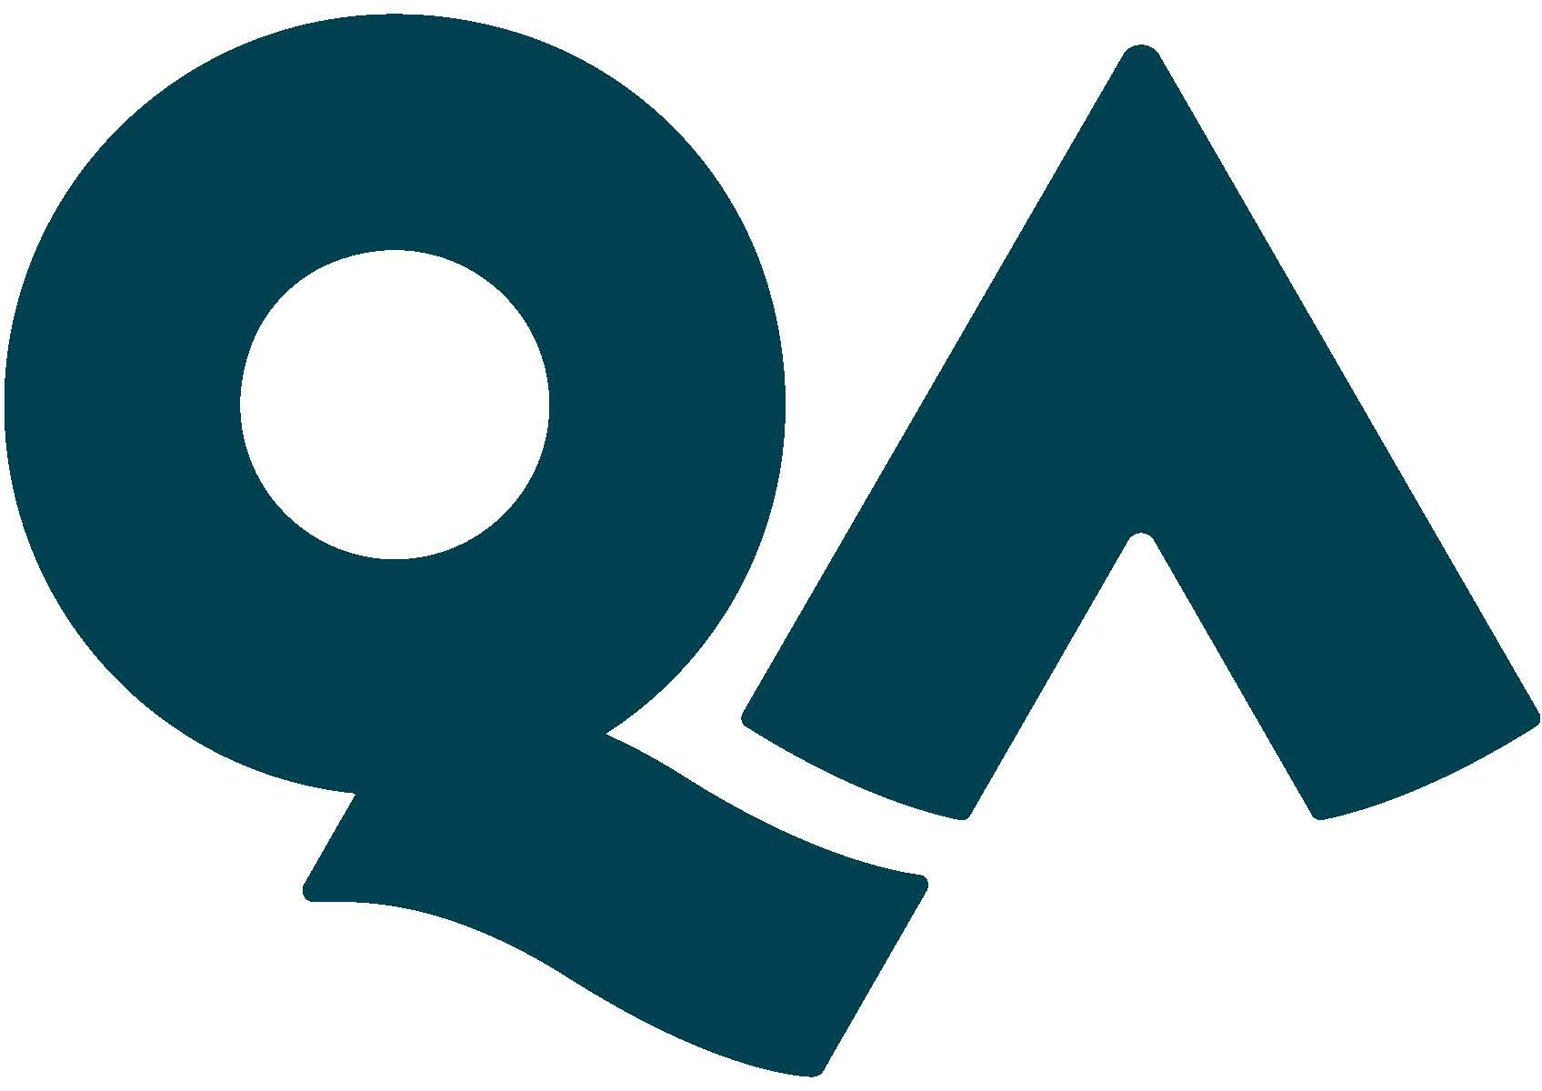

JOB
DESCRIPTION

- Job specifics
Job Title: | Senior Learning Designer
Reports to: | Senior Learning Design Manager
Location: | London / Home based (hybrid)
Department: | Content & Learning Design

- About the role
What you’ll be doing? | As a Senior Learning Designer you will:  - lead a team of Learning Designers and/or Junior Learning Designers to design high quality, engaging and innovative blended learning programmes for QA’s core products and bespoke courses for individual client requirements.  - support the Senior Learning Design Manager with the busy day to day operations of the Learning Design team.  - escalate project risks to the Learning Design Manager with a proactive approach to mitigate challenges.  - design and develop blended learning programmes for QA’s core products and for individual client requirements.  - work collaboratively and iteratively in Sprint teams with Learning Designers, Creative Producers, Video Producers, and Graphic Designers.  - quality assure the work of your team to ensure course specification documentation is accurate, up to date, and adheres to version control procedures.
Key Responsibilities | - Report project progress, updates, risks and challenges to the Senior Learning Design Manager.  - Oversee the time and resourcing priorities of your team to deliver projects on time.  - Monitor and support your team to manage their time effectively and keep them on track to meet the demanding requirements of the business.  - Mentor, motivate, and support the development of your team.  - Support your team members through, the analysis, design, development, implementation and delivery phases of digital learning content.  - Build strong working relationships with Subject Matter Experts (SMEs) to gain in depth understanding of course content, learning objectives, and learners’ skills requirements.  - Design, storyboard and script digital learning content and assets by applying learning design principles to effectively develop learners’ skills and knowledge.  - Quality assure your team’s work in line with course requirements, style guides, and course manuals.  - Conduct team meetings, and regular 121 reviews and performance evaluations.
KPIs & SLAs | You will ensue that the design and development of modules and other assets are completed to:  - specification  - time  - budget  - quality standards  Your success in the role will ultimately be measured by delivering better outcomes for learners and the client.
Key Working Relationships | You will regularly collaborate with the Learning Design Manager, Learning Designers, Creative Producers, Content Authors, Curriculum Managers, Graphic Designers and Video Producers.

- About You
Skills & Abilities | - Excellent people management skills.  - Builds working relationships and rapport quickly, even through remote intervention.  - Designs active learning to help learners to overcome potential barriers to progress and develop skills.  - Communicates complex ideas simply and concisely using the written word.  - Coordinates and manages educational projects, ranging across a wide variety of technical subjects.  - Identifies and escalates project risks in a timely manner.  - Possesses a strong understanding of innovative learning approaches and modern training techniques.  - Understands accessibility and copyright standards.  - Possesses high standards in accuracy, attention to detail and version control.  - Excellent spoken/written communication skills (English) with demonstrable writing and editing ability.
QA Competencies
Your Experience | - Track-record in:  - line management of learning design/instructional design teams.  - managing projects concurrently to defined timescales and budgets.  - successful design and development of digital and face-to-face learning programmes, preferably in an instructional/learning design role.  - quality assurance of educational products, ensuring pedagogical quality, technical reliability and consistency of content (educational scripts, videos, publications, textbooks, etc.).  - Practical know-how on VLE/LMS content creation and management.  - Practical know-how on rapid learning authoring tools.
Your Knowledge | Strong knowledge of educational theory and instructional/learning design principles.  A good knowledge of learning technology platforms and tools.
Your Qualifications | Relevant Higher Education Qualification or significant industry experience is essential
What you’ll bring to QA | - Positive, proactive and committed approach to delivering high quality work on time.  - Identifies opportunity and solutions, where others see stumbling blocks.  - Good planner and problem-solver.  - Demands high standards and sets the bar high through consistent and high-quality personal approach.  - Natural communicator.  - Team-player.

- About QA
About us | We shape the next generation of technologists, leaders and innovators.  By powering potential – the potential of over a quarter of a million learners a year. We empower them to push boundaries and thrive in the workplace.  Why we do learning  For over 30 years, we’ve worked in technology – where the impact of great learning is changing the world.  A bold statement, but hear us out. We are right at the centre of a technological revolution. Devices are not just connecting people, cities and countries – they are connecting to each other, collecting data and using it to learn and make themselves better. Soon we will have cars that can drive themselves, fridges that make sure we never run out of milk and computers that can learn from their own mistakes.  Driving this revolution? People.  And this is where we come in.  People advancing their knowledge in technology – to enrich society – build a new culture – better how we live our lives, and how we work together.  People are learning to use technology to drive phenomenal change. This is our passion – powering their potential.
We promise to be | Bold  - Ambition is great. We set ambitious targets – holding ourselves and others to ever-higher standards.  - We contribute (insightfully) to the debate inside and outside QA.  - We move. Quickly. We respond to your needs – fast.  Collaborative  - We spend time getting to know you – our learners and our customers – to earn your trust.  - We connect a solution to your problem – we have tonnes of different services to help you.  - We’re the positive person who actively gets stuck in to solving problems.  Progressive  - We embrace change – and support it.  - We challenge ourselves to use the latest technologies and methods – no matter how out there.  - We’re curious – about what you do, about what the person next to you does, about our customers and our learners.
What’s on offer? | Learning is not just a service we provide, it’s a way of life at QA, and we try to ensure that everyone has the opportunity to take advantage of our huge and varied range of learning and development options, so everyone is eligible for 3 Training Days every year, to focus on subjects they’re interested in.  We also know that many people like to “give back” and so we offer 2 paid Charity Days each year to support your chosen charity in whatever way you choose. And if you get involved in charity fundraising, QA will also double any sponsorship money raised, up to £250. This is over and above the charitable activities that we encourage through our annual QA fundraising drives – you can get involved with this as much or as little as you like. We see it as a great way to foster team building too.  We all need to take time out to recharge our batteries from time to time and enjoy some down time, so we provide a fairly generous 27 days’ holiday per annum (rising to 30 days after 5 years) – with the option to buy more if you wish.  It’s important, too, to plan for the future and ensure we are able to maintain the lifestyle we have worked so hard to achieve, once we retire from the hurly burly and slow down to enjoy our later years, so we offer a defined contribution pension plan and will match your contributions up to a maximum of 4% of your basic salary.  Then there are two of our core benefit offerings, not the most exciting, but we consider it important to ensure everyone has the peace of mind provided by Life Assurance (4x your basic salary) and Permanent Health Insurance (after a qualifying period) in the event that ill health, or worse, disrupts our plans.  And finally, a few fringe benefits to assist with travel and lifestyle choices:  - Season ticket loan  - Corporate gym membership  - Cycle to work scheme

